Wake County Public Schools 

***Information Systems***

**Data Warehouse Specification for**

**[*West Lake Elementary Data Warehouse*]**

May 6, 2023

**Table of Contents**

**Introduction 3**

**Purpose 3**

**Project Summary 4**

**Requirements Definition 4**

**Considerations 5**

**Document Change Log 5**

**Data Warehouse Specification**

**Introduction**

West Lake Elementary is a new school in Wake County. There’s approximately 225 students, causing more data to be managed. Administration has noticed student profiles obtaining errors and some students being mixed up. Administration and staff have been manipulating data using free text which has been causing the student profiles to lack accuracy, consistency, and students being mixed up with one another. This has affected valuable solutions to academic gaps, marketable numbers, and attainable goals for end of year testing. This document will introduce the solution to this problem followed by the requirements for the implementation.

The purpose of this document below is stating the data problem and introducing the solution. The project summary will describe the objectives, scope and outstanding issues. The requirements will describe the goals, usability requirements, security system requirements, business questions, data requirements, design constraints, and a diagram of the data warehouse. All of the information included in this document will assist with understanding how to implement the solution and what the new data warehouse will look like.

**Purpose**

The purpose of this project is to introduce the solution to a data problem West Lake Elementary has been facing. A solution to this problem will be to implement look-up tables. A look-up table is a table that shows a list of records that are meant to be displayed as drop downs. An example of this would be a failed name, ‘HR_Teacher.’ The values in a “Teacher” look- up table would reflect the names in the school. By using a lookup table, administrators will be able to manage data integrity and form executive decisions, teachers will be able to manipulate data efficiently, and the families of the students will monitor academic growth or academic gaps.

**Project Summary**

This section will provide detail of the importance behind implementing look-up tables to West Lake Elementary. The school will see a positive cultural difference from an administration perspective as well as the student and family perspective.. This section will provide an overview of what the look-up table will provide, what it will not provide, the measurable goals and the reasons of why this is being incorporated inside the data warehouse.

1. **Objectives**

Due to the necessity of providing a solution to secure and consistent data, Look-Up tables will provide the following for West Lake Elementary School:

1. Establish 100% error-free amongst all 225 student profiles and 101 teachers profiles
2. Increase consistent, real-time, data across the data warehouse by at least 60%
3. Provide opportunities for data analysis for future business opportunities and marketing advantages by March 2024
4. Look up tables must be implemented by Q3, July 2023
5. **Scope**

The look-up table will provide a convenient way for users to manipulate data by insertion, deletion, modification, and adding values. The value of having a lookup table inside the data warehouse will create posting change amongst West lake Elementary and allow students to understand their progress without error. The focus is to create a user-friendly data insertion environment for staff.

**In order to implement the look-up table to the school’s data warehouse, the following steps must be taken:**

**Step 1:**Create look-up spec

**Step 2:** Utilize JAVA API

**Step 3:** Specify attributes and values such as, (student name, student grade, student teacher, assignment, GPA, semester)

**Step 4:** After look-up table is created, users can delete, modify, and create attributes and values of the look tables from the console

* Deliverables for the Look-UP tables include the look up table itself and an upgraded UI for administrators, teachers, and families to manipulate.
* The implementation of the look-up table will not focus on the following:

1. Replacement of inserting grade values manually
2. Grading evaluations
3. Administrator communication
4. **References**

Ford, E., Oswald, M., Hassan, L., Bozentko, K., Nenadic, G., & Cassell, J. (2020). Should free-text data in electronic medical records be shared for research? A citizens' jury study in the UK. *Journal of medical ethics*, *46*(6), 367–377. <https://doi.org/10.1136/medethics-2019-105472>

K. J. Muhonen, M. Kavehrad and R. Krishnamoorthy. (2000) "Look-up table techniques for adaptive digital predistortion: a development and comparison," in *IEEE Transactions on Vehicular Technology*, 49( 5), 1995-2002 doi: 10.1109/25.892601.

Ponniah, P. (2010) Data Warehousing Fundamentals for IT Professionals. Wiley.

1. **Outstanding Issues**

* Grammatical errors
* Student profiles being mixed in with another student
* Unreliable data analysis
* Insufficient number of graded assignments

**Requirements Definition**

1. **Goals**
2. **Error free data:** Free text leaves room for mistakes and with a look-up table, data will be error free and consistent across the data warehouse.
3. **Convenience:** Teachers or other authorized users will not have to find assignments or any other grading elements when manipulating the data warehouse. Users will have the convenience of being provided options with a look-up table.
4. **Correct data insertion:** Teachers or other authorized users may incorrectly align assignments to a student. The Look-up table will allow users to insert correct information regarding the aligned student
5. **Consistent:** Incorrect data can cause student profiles to be inconsistent which can affect the school’s overall scoring system and other educational instances. Student profiles will be consistent and 100% accurate
6. **Analysis:** A school’s graduation rate, GPA score, etc. will have all of the calculated elements inside the data warehouse. Users will be able to analyze grading elements without error
7. **Accurate profiles:** All students will have 100% accuracy in grading with aligned assignments
8. **Future insights:** Data will be useful insight for future educational opportunities
9. **Quick Information Retrieval:** Users will be able to retrieve information quickly by using the drop down option look-up tables offer.
10. **Usability Requirements**
11. **Search-Methods:** Users should have the ability to search specific values using the drop down menu. This will prevent users from spelling mistakes and produce accurate data.
12. **Error-Free:** Look-Up tables will have the ability to provide the correct options. This will allow the data to be consistent and correct across student profiles, which is imperative for insightful analysis.
13. **Intuitive:** Intuitiveness will minimize confusion. The UI should be easy to use and options should be easy to understand.
14. **Drop-down Options:** The look-up table will have drop down options to help users identify the right values.
15. **Memory-efficient:** The look-up table will store data information
16. **System Security Requirements**
17. **Secure Moving Data:** There will be in-motion elements being tracked in real-time. Look up tables will store the information while the warehouse is constantly being fed. Securing moving data helps with analysis and data reporting.
18. **Administrative Access Control:** Specific users such as teachers will have a different access to specific options and other data information within the look-up table
19. **Teachers Access Control**: Teachers will have access to all student information and data with whom they teach. Other teachers may not have access to students that they do not teach
20. **Administrator Access Control:** Administrators will have access to all student and teacher information
21. **Parent Access Control:** Parents will only have access to their student and corresponding teacher’s profile, but not teacher data.
22. **Zero Trust:** Every user must be authenticated in order to have certain access to student’s data information
23. **Business Questions**
24. What practices are effective in the teacher-use of these tools?
25. What typeof education improvement will come into effect after implementing the look-up tables?
26. What software or data features will be most useful for users?
27. How will the school change as a result of these changes in data initiatives being implemented?
28. How will the data become impacted by using look-up tables?
29. **Data Requirements**

**Efficient Technology:** Teachers will have the convenience of choosing options rather than utilizing free-text and potentially having errors.

**Useful Insights:** The look-up tables not only store values, butwill allow the data to be consistent, creating accurate analysis to track scores for reports and other useful insights.

**Culture of Data Use:** Grading, tracking,reporting, etc will be less time consuming causing less stress on administration. This can also encourage more assignments to be given due to the task of tracking becoming less time-consuming.

**Data Integrity:** Look-up tables will make the database design become simple and scalable. Users can store key values for all modules on the application. Look-up tables will promote data integrity within the application.

1. **Design Constraints**
2. **Unique key constraints:** It’s imperative that there are no duplicate unique values within the tables
3. **Foreign key constraints**: If column A refers to column B inside the warehouse, column b can not be deleted
4. **Primary key constraints:** All primary key values must only be the only primary key to that table
5. **NOT NULL constraints:** There will be certain columns inside of the tables that can not be null

**Considerations:**

* What is the time frame to implement the server/firewalls for the warehouse?
* Who will we hire to construct the look-up tables?
* What is the budget needed for implementation?
* Who will be responsible for managing the warehouse?

**Document Change Log**

| **Change Date** | **Version** | **CR #** | **Change Description** | **Author and Organization** |
| --- | --- | --- | --- | --- |
| 04/18/2023 | 1.0 |  | Initial creation. | Diamond Burton |
| 04/26/2023 | 1.5 |  | ERD drafting | Diamond Burton |
| 04/26/2023 | 2.0 |  | Editing Purpose/summary/requirments | Diamond Burton |
| 04/30/2023 | 2.5 |  | Adding diagram | Diamond Burton |
| 05/01/2023 | 3.0 |  | Adding Data Dictionary | Diamond Burton |
| 05/02/2023 | 3.5 |  | Grammar check | Diamond Burton |
| 05/03/2023 | 4.0 |  | Editing constraints | Diamond Burton |

**Data Dictionary**

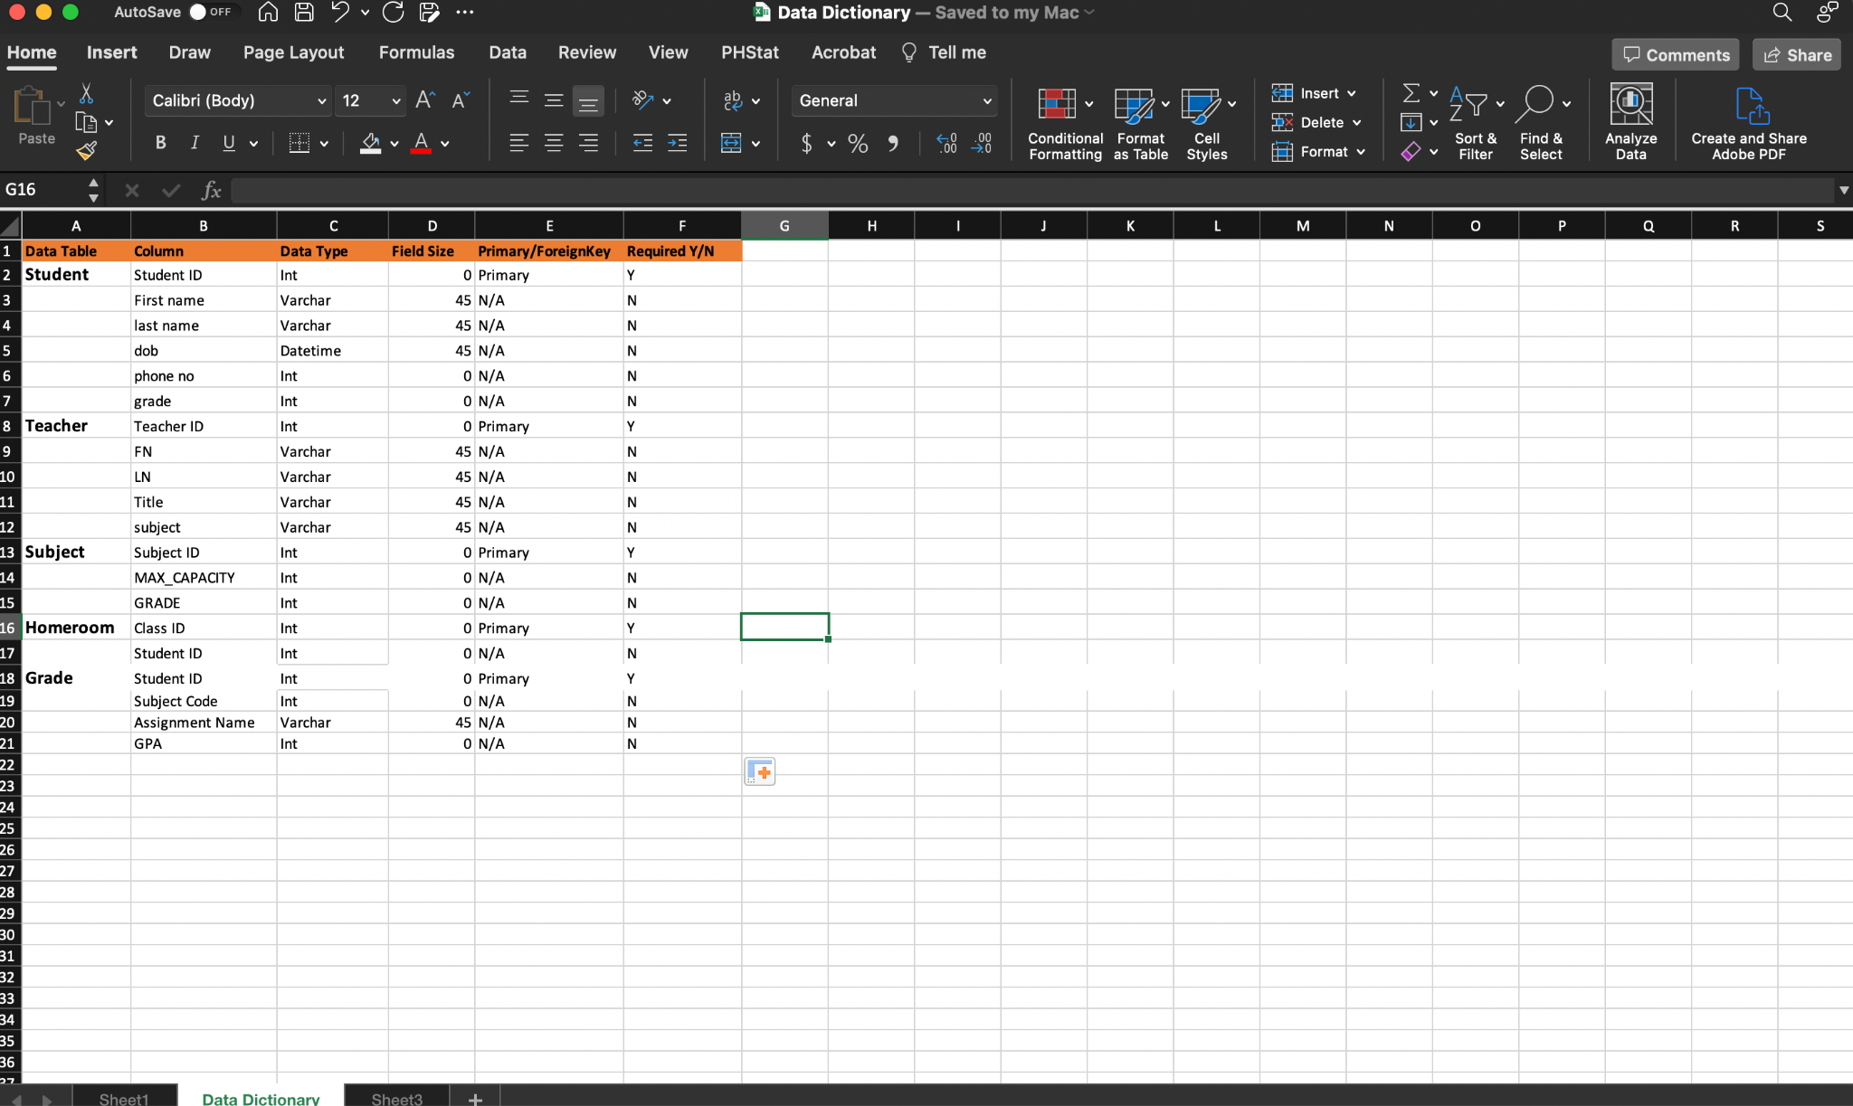

**ER-DIAGRAM**

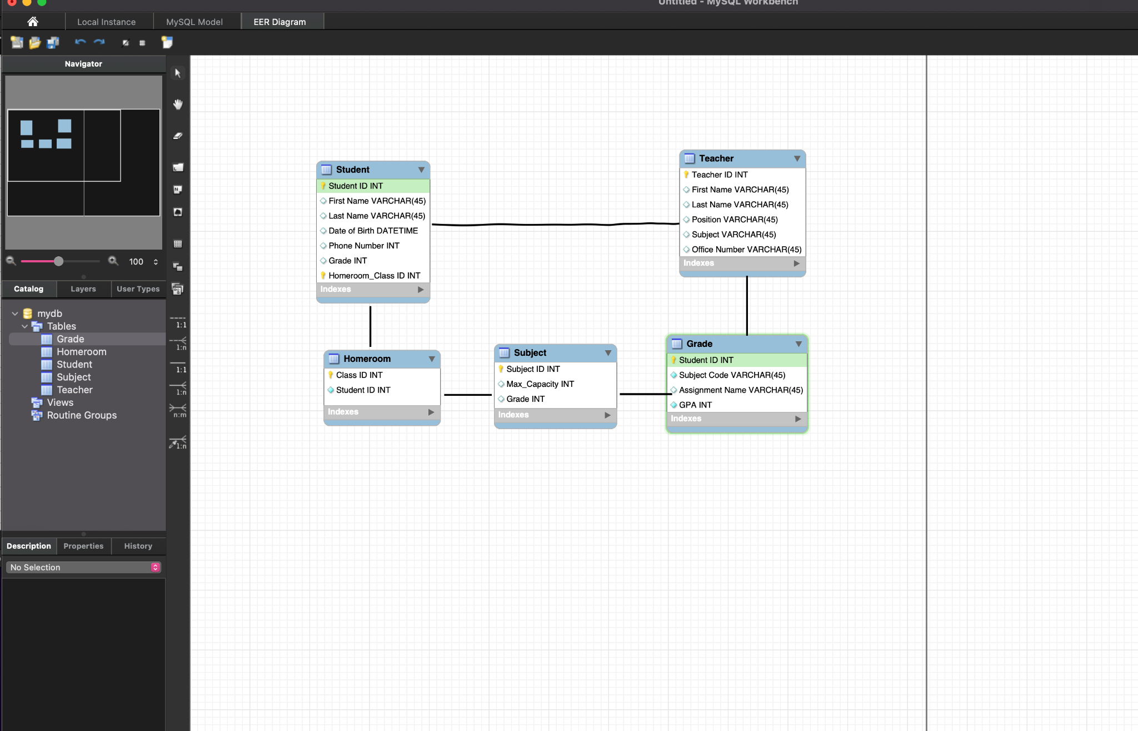

**Database Design** 